Implemented from [here](https://www.youtube.com/playlist?list=PL0hT6hgexlYys_9UWhal1kr9Gkz0ms0sM)

Question 1: can someone from non IT background do it?

Question 2: why a company should opt for ISO27001, because it’s a global standard instead of focusing one for each geographical location or one for each domain you can hit all in one, you can integrate others in it too  
Bonus Question: why a company should even get certify; to create a relationship of trust between consumers and producers.

Question 3: Why should you invest in ISO27001? For products when you ship the customer does not have to test security controls because a third party audit has already proven those things. Evaluation against a benchmark.

Question 4: How to implement ISO27001? It took 6 months to a year to fully implement.

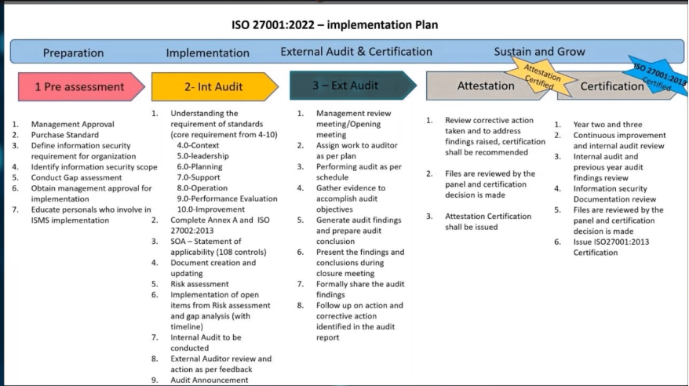

System of Applicability

